**Experiment No: 03**

**Experiment name:**

(i) A program to insert an element into a stack (push) and delete an element from a stack (pop).

**Objectives:**

To study, write program and check its result to insert an element into a stack and delete an element from a stack.

**Pseudo code 1:**

|  |  |
| --- | --- |
| #include<stdio.h>  main()  {  int a[20],top=-1,maxsize=4,value,i,j,n;  for( ; ;){  printf("Enter your option\n");  scanf("%d",&n);  if(n==1)  {  if(top==maxsize)  printf("Overflow\n");  else  {  printf("Enter your value\n");  scanf("%d",&value);  top=top+1;  a[top]=value;  printf("Data succesfully inserted\n");  }  }  else if(n==2) | {  if(top==-1)  printf("Underflow\n");  else  {  a[top]=NULL;  top=top-1;  printf("Data succesfully deleted\n");  }  }  else if(n==3)  {  printf("stack values are\n");  for(j=0;j<=top;j++)  printf("%d\n",a[j]);  }  else  exit(0);  }  } |

**Result 1:**

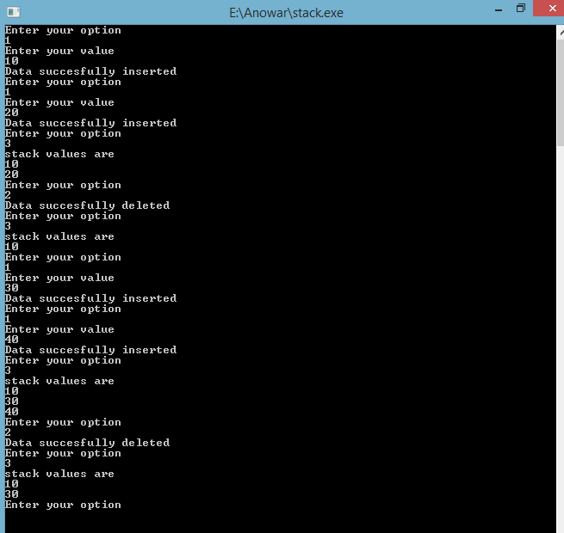

**Discussion:**

There are two types of stack. One is push another pop .Push is insert an element into a stack and pop is delete an element from a stack .In the push, if the top is equal to max size then stack is overflow, Otherwise value is inserted .In the pop, if the element is zero then stack is underflow or delete is impossible. Otherwise value is deleted. Firstly, I face many problems to solve this problem. Then our honorable teacher help us to solve this problem .Finally I easily solve this problem.